

Touchstones Project REACH
(Religious Education Arts Clearing House)

Lifespan RE Resources for Play

Introduction
This packet explores the theme of Play. It draws on two principles and one source:

- 4th principle: A free and responsible search for truth and meaning / We believe that each person must be free to search for what is true and right in life.
- 7th principle: Respect for the interdependent web of all existence of which we are a part. / We believe in caring for our planet Earth, the home we share with all living things.
- 1st source: Direct experience of that transcending mystery and wonder, affirmed in all cultures, which moves us to a renewal of the spirit and an openness to the forces which create and uphold life / The sense of wonder we all share.

Play is crucial in the development and well-being of children. Play promotes the following.
Play plays a crucial role. It is not just a form of entertainment but a fundamental aspect of growth, learning, and socialization per the following.
- Thinking: Play stimulates children’s thinking, problem-solving abilities, critical thinking, decision-making, and creativity. Through play, children explore, experiment, and make sense of the world around them. It encourages their curiosity, imagination, and the development of critical cognitive skills such as memory, attention, and logical reasoning.
- Feeling: Play provides an outlet for children to both express and regulate their emotions. It allows them to experience and explore feelings like joy, fear, frustration, and empathy. Through pretend play, children can explore different roles and scenarios, which can help contribute to perspective-taking and emotional intelligence. Pretend play allows a child to walk in another’s shoes.
- Socially: Play allows children to interact and engage with their friends, siblings, and caregivers. Children develop social skills through these interactions, like communication, cooperation, negotiation, sharing, and taking turns. They learn about social norms and relationships while creating a sense of belonging.
- Well-being: Active play promotes healthy growth and physical fitness, including developing small and large motor skills, coordination, balance, and strength. Play serves as a stress reliever for children. It allows them to unwind, relax, and recharge their energy, which promotes psychological well-being, reduces anxiety, and fosters a positive outlook on life.

Encouraging and providing ample play opportunities is crucial for children’s growth, learning, and overall well-being.

Play is complex. As Einstein said, “Understanding physics is child’s play when compared to understanding child’s play.” Play is an essential part of childhood development. It helps children explore, learn, and develop various skills. Common types of play include:
- Active/Physical Play
- Imaginative/Make-Believe Play
- Constructive/Building Play
- Social/Cooperative Play
- Sensorial/Exploratory Play
- Creative/Artistic Play
- Cognitive/Problem-Solving Play
- Outdoor/Nature Play

It’s important to note that these categories are not mutually exclusive, and many forms of play can overlap or incorporate multiple types.

While some educators may draw a line between play and education, the boundary is porous. Some educational approaches, like Montessori and Reggio Emilia, utilize hands-on, experiential learning and incorporate play-based activities into their curricula. Child’s play and education are distinct, but they are not incompatible. Play can be an effective tool for education, especially for young children.

Child’s play is characterized by spontaneity, imagination, and enjoyment. It provides children with opportunities for creativity, problem-solving, and social interaction. By contrast, education is an intentional process of acquiring knowledge and skills through formal instruction. Education promotes children's intellectual, emotional, social, and physical development.

While play and education may seem different in their approaches, they are not mutually exclusive. Playful learning approaches recognize children's innate curiosity and joy, utilizing play to promote various aspects of education.

For more background about the complexity of play and its value see 6.2, 6.6, 6.8 & 6.10 below.

Resources for Children
1.0: Pins
2.0: Wisdom Stories
The Tapestry of Faith stories are not listed since those are easily accessible in the curricula listed at 4.0 & 5.0:
2.1: Hide-and-Seek with God by Mary Ann Moore (704 words)
2.2: Insults for Free by the Christian Desert Fathers (133 words)
3.0: Children’s Books
3.1: Not a Box by Antoinette Portis (2006)
3.2: Not a Stick by Antoinette Portis (2007)
3.3: The Wonderful Things You Will Be by Emily Winfield Martin (2015)
3.4: Tap the Magic Tree by Christie Matheson (2013)
3.5: Can I Play Too? by Mo Willems (2010)
3.6: I Ain’t Gonna Paint No More! by Karen Beaumont (Author) and David Catrow (Illustrator) (2005)
3.7: Jabari Jumps by Gaia Cornwall (2017)
3.8: Play by Jez Alborough (2018)
3.9: The Day the Crayons Quit by Drew Daywalt, author and Oliver Jeffers, illustrator (2013)
3.10: We All Play: Kimêtawânaw by Julia Fett (2021)
3.11: Run Wild by David Covell (2018)
3.12: A Stick Is an Excellent Thing: Poems Celebrating Outdoor Play by Marilyn Singer (Author) and LeUyen Pham (Illustrator) (2012)
3.13: The Paper Kingdom by Helena Ku Rhee (Author) and Pascal Campion (Illustrator) (2020)
3.14: Move! by Robin Page (Author) and Steve Jenkins (Illustrator) (2006)
3.15: How to Find Gold by Viviane Schwarz (2016)
3.16: What If... by Samantha Berger, author & Mike Curato, illustrator (2018)
3.17: What to Do With a Box by Jane Yolen, author & Chris Sheban, illustrator (2016

3.18: Odd Velvet by Mary Whitcomb, author & Tara Calahan King, illustrator (1998)
3.19: The Whisper by Pamela Zagarenski (2015)
3.20: On a Beam of Light: A Story of Albert Einstein by Jennifer Berne, author & Vladimir Radunsky, illustrator (2013)
3.21: Harold and the Purple Crayon by Crockett Johnson (1955)
3.22: Salad Pie by Wendy BooydeGraaff (Author) and Bryan Langdo (Illustrator) (2016)
3.23: The Tea Party in the Woods by Akiko Miyakoshi (2015)
3.24: Wonder Walkers by Micha Archer (2021)
3.25: Outside In by Deborah Underwood, author and Cindy Derby, illustrator (2020)

3.26: Finding Wild by Megan Wagner Lloyd, author and Abigail Halpin, illustrator (2016)

3.27: A Walk in the Forest by Maria Dek (2017)
3.28: Backyard Fairies by Phoebe Wahl (2018)
3.29: The Rainbow Fish by Marcus Pfister (1996)
3.30: We’re Going on a Bear Hunt by Michael Rosen (Author) and Helen Oxenbury (Illustrator) (1989)

3.31: The Recess Queen by Alexis O’Neill, author and Laura Huliska-Beith, illustrator (2002)
3.32: Strictly No Elephants by Lisa Mantchev, author and Taeeun Yoo, illustrator (2015)
3.33: Pretend by Jennifer Plecas (2011)
3.34: Rosie Revere, Engineer by Andrea Beaty, author and David Roberts, illustrator (2013)
3.35: Mae Among the Stars by Roda Ahmed, author & Stasia Burrington, illustrator (2018)
4.0: Curriculum & Theme-Based Classroom Activities for Children

from Tapestry of Faith
4.1: Chalice Children: A Program about Our Unitarian Universalist Community for Preschoolers
4.1.1: Session 17: Wondering About Stars
4.1.2: Session 18: Wondering About the Moon
4.1.3: Session 20: Rainbows
4.1.4: Session 21: Dreams
4.1.5: Session 22: Imagination
4.2: Creating Home: A Program on Developing a Sense of Home Grounded in Faith for Grades K-1
4.2.1: Session 1: On the Threshold
4.2.2: Session 8: Hare’s Gifts
4.3: Wonderful Welcome: A Program for Children Grades K-1
4.3.1: Session 6: The Gift of Friends
4.4: Love Surrounds Us: A Program on the UU Principles and Beloved Community for Grades K-1
4.4.1: Session 6: Acceptance
4.5: Moral Tales: A Program on Making Choices for Grades 2-3
4.5.1: Session 3: Faith, Hope and Prayer
4.5.2: Session 6: Welcome One and All
4.6: Faithful Journeys: A Program about Pilgrimages of Faith in Action for Grades 2-3
4.6.1: Session 5: Finding Balance
4.7: Love Will Guide Us: A Program for Grades 2-3 that Applies the Wisdom of the Six Sources to the Big Questions
4.7.1: Session 10: Love for All Creatures
4.8: Signs of Our Faith: A Program about Being UU Every Day for Grades 2-3
4.8.1: Session 9: Looking for Signs of Community
4.8.2: Session 11: Worshipping Together
4.9: Toolbox of Faith: A Program That Helps Children Discover the Uses of Faith, Grades 4-5
4.9.1: Session 16: Resiliency (Hard Hat)
4.10: Love Connects Us: A Program on Living in Unitarian Universalist Covenant for Grades 4-5
4.10.1: Session 3: Love is the Spirit of this Church
4.10.2: Session 16: We are Active Creators of our Faith
4.11: Sing to the Power: A Social Justice Program for Children Grades 4-5
4.11.1: Session 2: The Power of Roots
4.12: Riddle and Mystery: A Program on the Big Questions for Grade 6
4.12.1: Session 14: Life as Mystery
4.13: Circle of Trees: A Multigenerational Program about Nourishing Deep Connections with Nature
4.13.1: Workshop 3: Trees: Connected to All Life
4.14: Wisdom from the Hebrew Scriptures: A Multigenerational Program
4.14.1: Workshop 8: Creation
4.15: Heeding the Call: A Program on Justice-making for Junior High School Youth
4.15.1: Workshop 9: The Call for Imagination

Resources for Youth
5.0: Curriculum & Theme-Based Classroom Activities for Youth
Tapestry of Faith
Youth
No sessions identified in Tapestry of Faith. Consider using 4.13.1, 4.14.1, and 4.15.1.
6.0: Readings
6.1: Conscious Completion by Rosie Bell (153 words)
6.2: Seven Properties of Play (302 words)
6.3: The Sheep by Lewis Hyde (241 words)
6.4: Meaning: Where Monk and Child Meet by David Steindl-Rast (240 words)
6.5: Relief Not Cure by Anthony DeMello (224 words)
6.6: Rough-and-Tumble Play & Empathy by Start Brown (269 words)
6.7: Catching Bubbles by Les Kaye (121 words)
6.8: Finite and Infinite Games (196 words)
6.9: Play Needs No Purpose by Parker Palmer (237 words)
6.10: The Play Deficit by Peter Gray (267 words)
6.11: Deep Play and Higher Consciousness by Diane Ackerman (268 words)
6.12: Play is the Thing by Peter Gray (271 words)
6.13: The Cosmic Play by David Zeller (268 words)
6.14: Innate Talents by Stuart Brown (228 words)
6.15: Play Washes Ambition Out of the Soul by Joan Chittister (279 words)
6.16: Play as Re-creation by Patrick Thomas Malone and Thomas Patrick (250 words)
6.17: Action Without Desire Of Outcomes by Vinoba Bhave (200 words)
6.18: Who Am I? by Author Unknown (258 words)
6.19: The Cosmic Café by Marney Makridakis (253 words)
6.20: The Core of Contemplative Life by Patricia Hampl (197 words)
7.0: Popular Music
7.1: The Circle Game by Joni Mitchell A & Buffy Saint Marie B
7.2: Happy by Pharrell Williams (4:00)
7.3: See Emily Play by Pink Floyd (2:48)
7.4: Video Game (with lyrics) by Sufjan Stevens (4:37)
7.5: The Play by Peter Mayer (5:12)
7.6: Blue Boat Home by Peter Mayer (4:02)
7.7: Jama Day by Peter Mayer (2:59)
7.8: Snuffleupagus by Peter Mayer (3:30)
7.9: Magical World by Peter Mayer (3:56)
7.10: Ocean Mary by Peter Mayer (4:08)
7.11: Astronaut Dreams by Peter Mayer (4:05)
7.12: Running with the Buffalo by Peter Mayer (4:30)
7.13: Molly O’Malley’s by Peter Mayer (3:26)
7.14: Fall by Peter Mayer (3:01)
7.15: Camping By the Sun by Peter Mayer (4:37)
7.16: Could You Be by Peter Mayer (4:37)
8.0: Videos
8.1: Importance of Play by Dr. Jeffrey Trawick-Smith (2:37)
8.2: The Power of Play by UNICEF South Africa (4:59)
8.3: The Importance Of Real Play by PersilUK (2:05)
8.4: Importance of Play by Karen Hutchison (2:15)
TED Talks
8.5: The Transformative Power of Play by Emeka Nnadi (14:50)
8.6: Play is more than just fun by Stuart Brown (26:42)
8.7: The decline of play by Peter Gray (16:03)
8.8: 5 dangerous things you should let your kids do by Gever Tulley (9:20)
8.9: The Power of Play by Ash Perrin (15:52)
8.10: Never Too Old to Play: Rethinking American Playgrounds by Meghan Talarowski (13:41)
8.11: The importance of play by John Cohn (18:27)
8.12: Evolution’s gift of play, from bonobo apes to humans by Isabel Behncke (7:01)
8.13: 5 dangerous things you should let your kids do by Gever Tulley (9:20)
8.14: The Power of Play by Charlie Hoehn (13:44)

List of Resources
Resources for Children

1.0: Pins
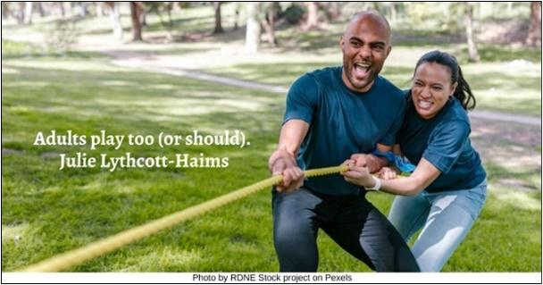

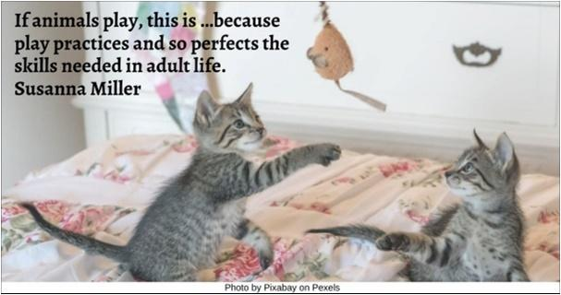

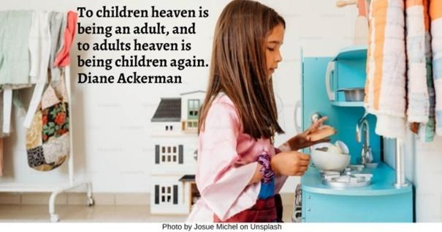

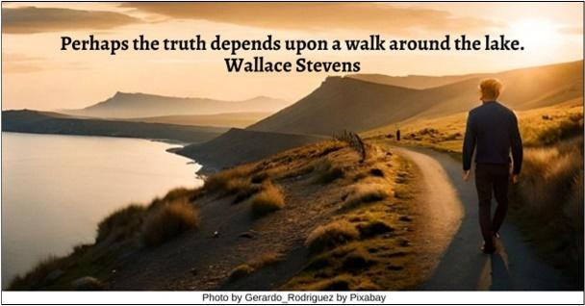

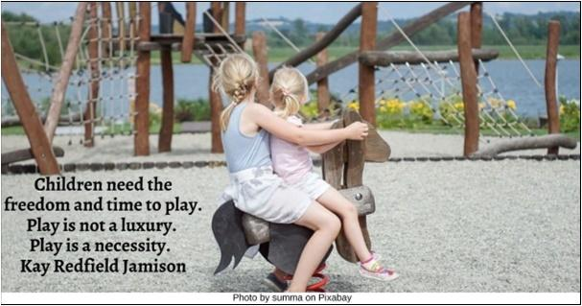

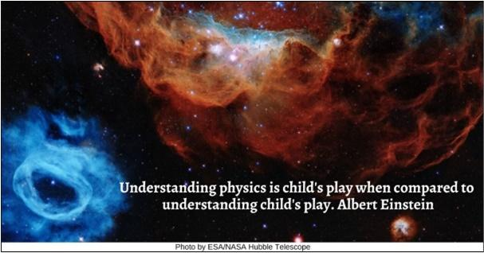

Resources for Children
2.0: Wisdom Stories
The Tapestry of Faith stories are not listed since those are easily accessible in the curricula listed at 4.0 & 5.0:
2.1: Hide-and-Seek with God by Mary Ann Moore (704 words)
Once upon a time, God said, “I’m bored because I don’t have anything to do. I want to play with my friends.” And because God is God, as soon as the words were spoken, God’s friends were there. When God saw them all gathered, God said, “I’ve been bored because I haven’t had anything to do. Let’s play something.”
“Good idea,” said God’s friends. “What shall we play?”
God thought for a minute and then said, “I know, let’s play hide-and-seek!”
The friends all said, “Yay!” They knew that hide-and-seek with God was always exciting and different because God was the one who hid and God always thought of wonderful places to hide.
God’s friends closed their eyes tight and counted to ten. When they opened their eyes, God wasn’t there anymore. So they all went off to look for God.
One friend decided to look close on the earth and soon came to a meadow. As he was searching, he stopped to admire the tender new sprouts of green grass pushing their way up toward the sun. As he bent over to look more closely at the tender green, he realized there was something special and amazing and wonderful about it. So he jumped up and ran back to home base, calling out, “I found God! God is green and growing. I found God in the grass!”
Another one of God’s friends decided to look for God in the night. She watched the sun go down, and heard the work-a-day noises stop, and saw the lights in the houses go out. As it got darker and the peaceful night wrapped itself around her, she listened very hard, and then she realized there was something special and amazing and wonderful about it. And when it was so still that she could see and hear nothing at all, she suddenly jumped up and ran to home base, calling out, “I found God! God is dark and peaceful. I found God in the night!”
A third friend looked on the earth and felt the mystery of the grass growing toward the sun. He stayed and watched the night come on, and he felt the mystery of the darkness and the stars. He thought to himself, “These mysteries are special and amazing and wonderful.” But when he finally came back to home base, he said, “I found wonderful mysteries but I’m not sure if I want to call them God.”
A fourth friend decided to look for God where people were. He joined a group of people going home from work and went with them into the store where they bought food. He went with them back out on the street as they started for their homes. He was with them when someone came up and said, “Please, I’m very hungry. Could you share a little food with me?” The people readily agreed and as he watched them share, he realized there was something special and amazing and wonderful about those people. He turned around and ran to home base, calling out, “I found God! God is love and sharing. I found God in people who care for others!”
Finally, two more of God’s friends, a boy and a girl, decided to look for God together. After a time, they came to a house and decided to look for God in the house. In the house they saw a room, and they looked for God in the room. In the room they saw a mirror, and they looked for God in the mirror. As they looked into the mirror, they realized there was something special and amazing and wonderful being reflected in it. They turned around and ran to home base, calling out, “We found God! We found God in us!”
At this God appeared again and said, “I had so much fun! Weren’t those good hiding places? Some of you found me, others weren’t sure, and others are still looking. That’s OK because the most important thing is just to play the game. Let’s do it again! I’m sure I can think of some other good hiding places.” And they all called out, “Olly, olly, oxen free, free, free!” And the game started all over again.
Source: https://www.uua.org/worship/words/reading/5953.shtml

2.2: Insults for Free by the Christian Desert Fathers (133 words)
The Christian Desert Fathers tell of a new student who was commanded by his master that for three years he must give money to everyone who insulted him. When this period of trial was over, the master said, “Now you can go to Alexandria and truly learn wisdom.” When the student entered Alexandria, he met a certain wise man whose way of teaching was to sit at the city gate insulting everyone who came and went. He naturally insulted the student also, who immediately burst out laughing. “Why do you laugh when I insult you?” said the wise man. “Because,” said the student, “for years I’ve been paying for this kind of thing, and now you give it to me for free!” “Enter the city,” said the wise man. “It is all yours.”
Source: Breath Sweeps Mind: A First Guide to Meditation Practice, edited by Jean Smith

3.0: Children’s Books
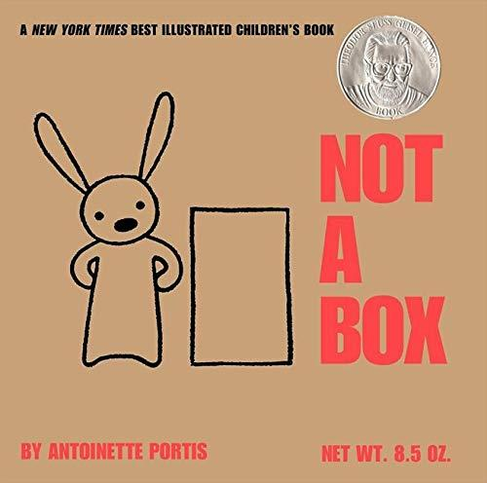
3.1: Not a Box by Antoinette Portis (2006)
“A box is just a box...unless it’s not a box. From mountain to rocket ship, a small rabbit shows that a box will go as far as the imagination allows.
“Inspired by a memory of sitting in a box on her driveway with her sister, Antoinette Portis captures the thrill when pretend feels so real that it actually becomes real—when the imagination takes over inside a cardboard box, and through play, a child is transported to a world where anything is possible.
“After reading this book aloud, continue the fun by drawing shapes like a triangle or circle, and asking your child what the triangle is NOT!”
Video Link: https://www.youtube.com/watch?v=svlNiELjDao (2:05) (read twice in the clip)

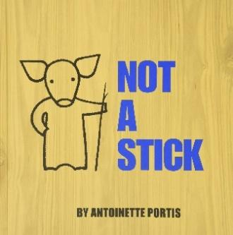
3.2: Not a Stick by Antoinette Portis (2007)
“Experience the thrill of the moment when pretend feels so real that it actually becomes real!
“…this book proves that a stick is not always just a stick. Whether it’s conducting an orchestra, painting a masterpiece, or slaying a dragon—give a child a stick and let imagination take over and the magic begin.”
Video Link: https://www.youtube.com/watch?v=jwqxd4SfNcw (2:13) (read twice in the clip)

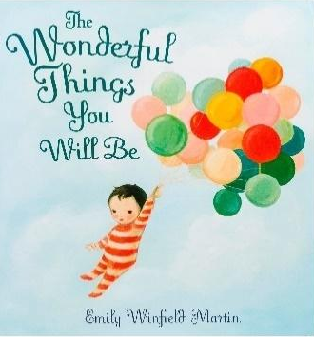
3.3: The Wonderful Things You Will Be by Emily Winfield Martin (2015)
“This beautifully illustrated book encourages children to explore their imagination and play freely while embracing their uniqueness.”
Video Link: https://www.youtube.com/watch?v=gYqEsoAfhPQ (2:57)

3.4: Tap the Magic Tree by Christie Matheson (2013)
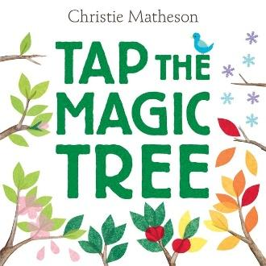
“Every book needs you to turn the pages. But not every book needs you to tap it, shake it, jiggle it, or even blow it a kiss. Innovative and timeless, Tap the Magic Tree asks you to help one lonely tree change with the seasons. Now that’s interactive—and magical!
“It begins with a bare brown tree. But tap that tree, turn the page, and one bright green leaf has sprouted! Tap again—one, two, three, four—and four more leaves have grown on the next page. Pat, clap, wiggle, jiggle, and see blossoms bloom, apples grow, and the leaves swirl away with the autumn breeze”
Video Link: https://www.youtube.com/watch?v=3e7FFxElbw4 (2:04)

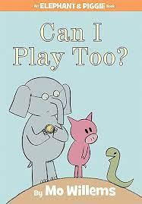
3.5: Can I Play Too? by Mo Willems (2010)
“Gerald, the elephant, and Piggie meet a new snake friend who wants to join in a game of catch. But don’t you need arms to catch?”
Video Link: https://www.youtube.com/watch?v=8vbr81Vf9Hc (3:01)

3.6: I Ain’t Gonna Paint No More! by Karen Beaumont (Author) and David Catrow (Illustrator) (2005)
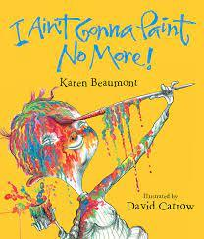
“This energetic and colorful book tells the story of a child who cannot resist the urge to paint on everything, leading to hilarious results.”
Video Link: https://www.youtube.com/watch?v=hMHClT65K6I (3:57

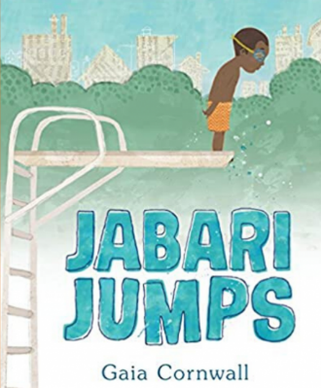
3.7: Jabari Jumps by Gaia Cornwall (2017)
“This book follows Jabari, a young boy who must summon up the courage to jump off the diving board for the first time, embracing the joy and exhilaration of play.”
Video Link: https://www.youtube.com/watch?v=Q4tAXar8uIA (4:40)

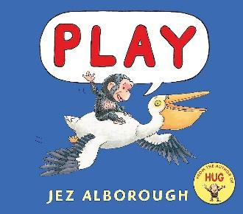
3.8: Play by Jez Alborough (2018)
“It’s bedtime for Bobo, but the little chimp isn’t ready to stop playing for the day. So, he hitches a ride on an obliging giraffe, only to be carried back to his mother when she calls. His mother tells him again to stay, but Bobo can’t help catching a lift on the back of a turtle to see what’s across the pond and on top of a nearby hill. Now it’s getting dark, and he’s all alone, with no idea how to get home. ‘Mommy!’”
Video Link: https://www.youtube.com/watch?v=mTYzOtXg5DI (6:44)

3.9: The Day the Crayons Quit by Drew Daywalt, author and Oliver Jeffers, illustrator (2013)
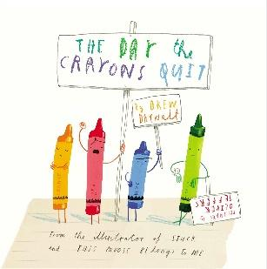
“Poor Duncan just wants to color. But when he opens his box of crayons, he finds only letters, all saying the same thing: His crayons have had enough! They quit! Blue crayon needs a break from coloring all those bodies of water. Black crayon wants to be used for more than just outlining. And Orange and Yellow are no longer speaking—each believes he is the true color of the sun. What can Duncan possibly do to appease all of the crayons and get them back to doing what they do best?”
It’s really bad when your crayons are discontent!
Video Link: https://www.youtube.com/watch?v=hH9WXSoBX5w (6:59)

3.10: We All Play: Kimêtawânaw by Julia Fett (2021)
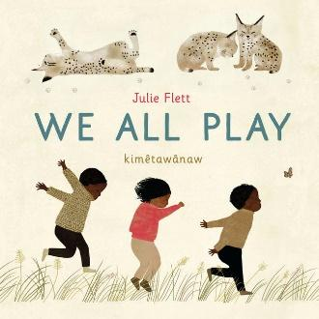
“Animals and kids love to play! This wonderful book celebrates playtime and the connection between children and the natural world. Beautiful illustrations show:
*birds who chase and chirp!
*bears who wiggle and wobble!
*whales who swim and squirt!
*owls who peek and peep!
and a diverse group of kids who love to do the same, shouting: We play too! / kimêtawânaw mîna
“At the end of the book, animals and children gently fall asleep after a fun day of playing outside, making this book a great bedtime story.” Julia Fett is a Cree author.
Video Link: https://www.youtube.com/watch?v=Yu8V_e1z_gE (3:31)

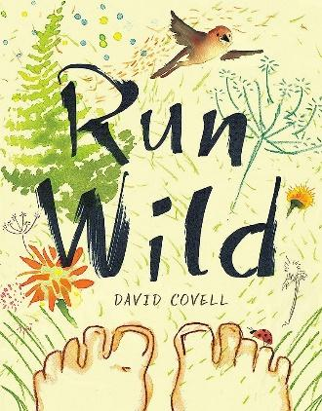
3.11: Run Wild by David Covell (2018)
“‘Hey, you! Sky’s blue!’ a girl shouts as she runs by the window of a boy bent over his digital device. Intrigued, the boy runs out after her, leaving his shoes (and phone) behind, and into a world of sunshine, dewy grass, and warm sand. Filled with the pleasures of being alive in the natural world, Run Wild is an exquisite and kid-friendly reminder of how wonderful life can be beyond doors and screens.”
Video Link: https://www.youtube.com/watch?v=3GUs6xPAKQ8 (3:03)

3.12: A Stick Is an Excellent Thing: Poems Celebrating Outdoor Play by Marilyn Singer (Author) and LeUyen Pham (Illustrator) (2012)
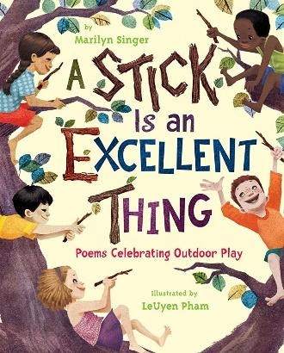
“The trappings of childhood change from generation to generation, but there are some timeless activities that every kid loves. Marilyn Singer and LeUyen Pham celebrate these universal types of play, from organized games such as hide-and-seek and hopscotch to imaginative play such as making mud soup or turning a stick into a magic wand. Lyrical poems and bold illustrations capture the energy of a group of children in one neighborhood as they amuse themselves over the course of a summer day.”
Video Link: https://www.youtube.com/watch?v=6_cB74vDtFw (8:23) (reading starts at 0:40)

3.13: The Paper Kingdom by Helena Ku Rhee (Author) and Pascal Campion (Illustrator) (2020)
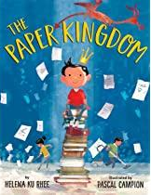
“When the babysitter is unable to come, Daniel is woken out of bed and joins his parents as they head downtown for their jobs as nighttime office cleaners. But the story is about more than brooms, mops, and vacuums. Mama and Papa turn the deserted office building into a magnificent kingdom filled with paper. Then they weave a fantasy of dragons and kings to further engage their reluctant companion--and even encourage him to one day be the king of a paper kingdom.”
Video Link: https://www.youtube.com/watch?v=aa3VSkX_1ec (7:07)

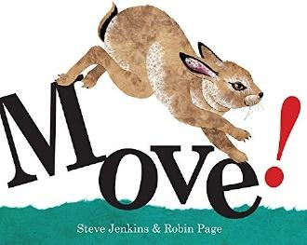
3.14: Move! by Robin Page (Author) and Steve Jenkins (Illustrator) (2006)
“Animals move! Follow them as they swing, dance, float, leap, and slide from page to page, then learn why these animals move the way they do, from the jumping spider who dances to impress and then floats away on a thread of silk, to the roadrunner who flies, but not too far, and would rather run to catch its prey.” This book invites children to move like the different animals as a wonderful way of having fun.”
Video Link: https://www.youtube.com/watch?v=jJjQi7LJHfg (2:46)

3.15: How to Find Gold by Viviane Schwarz (2016)
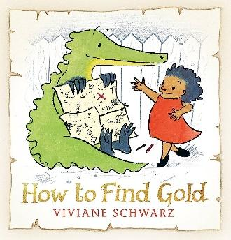
“Anna and Crocodile head out on an adventure to find gold. Together, they draw a map to find their gold. Crocodile draws and tells a story about pirate ships and sea monsters. They head out to sea on their adventure until they find their treasure.
Children will love the chance to create their own map. Trade maps with a friend and see if you can follow their directions to find the riches. Imagine the pirates are after your treasure. Write a creative story to tell what happens. Act out the story. You can even make props and costumes to go with it.”
Video Link: https://www.youtube.com/watch?v=vxWlWJUfMEo (6:13)

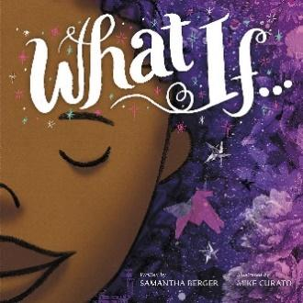
3.16: What If... by Samantha Berger, author & Mike Curato, illustrator (2018)
“This girl is determined to express herself! If she can’t draw her dreams, she’ll sculpt or build, carve or collage. If she can’t do that, she’ll turn her world into a canvas. And if everything around her is taken away, she’ll sing, dance, and dream....”
Video Link: https://www.youtube.com/watch?v=Z2jcTiu9qhc (4:03)

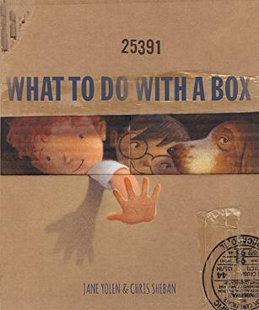
3.17: What to Do With a Box by Jane Yolen, author & Chris Sheban, illustrator (2016
“If you give a child a box, who can tell what will happen next? It may become a library or a boat. It could set the scene for a fairy tale or a wild expedition. The most wonderful thing is its seemingly endless capacity for magical adventure, a feature imaginatively captured in cardboardesque art by Chris Sheban and rhythmically celebrated in this poetic tribute by …author Jane Yolen.”
Video Link: https://www.youtube.com/watch?v=AyFpB0xe0j8&t=82s
(2:41)

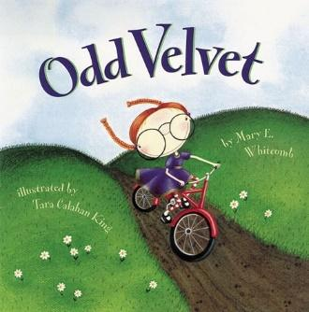
3.18: Odd Velvet by Mary Whitcomb, author & Tara Calahan King, illustrator (1998)
“Velvet is odd. Instead of dolls that talk and cry, Velvet brings a milkweed pod for show and tell. She wins the class art contest using only an eight-pack of crayons. She likes to collect rocks. Even her name is strange-Velvet! But as the school year unfolds, the things Velvet does and the things that Velvet says slowly begin to make sense. And, in the end, Velvet’s classmates discover that being different is what makes Velvet so much fun.”

Video Link: https://www.youtube.com/watch?v=Jg-Fzg6mmkQ (4:59)

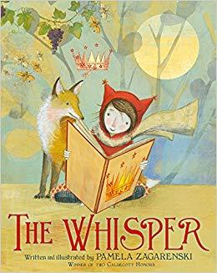
3.19: The Whisper by Pamela Zagarenski (2015)
“Step inside the pages of a little girl’s magical book as she discovers the profound and inspiring notion that we each bring something different to the same story.”
Video Link: https://www.youtube.com/watch?v=utnneKUePUw (10:08)

3.20: On a Beam of Light: A Story of Albert Einstein by Jennifer Berne, author & Vladimir Radunsky, illustrator (2013)
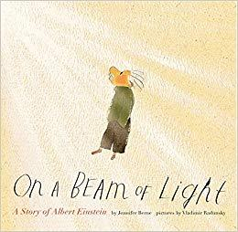
“A boy rides a bicycle down a dusty road. But in his mind, he envisions himself traveling at a speed beyond imagining, on a beam of light. This brilliant mind will one day offer up some of the most revolutionary ideas ever conceived. From a boy endlessly fascinated by the wonders around him, Albert Einstein ultimately grows into a man of genius recognized the world over for profoundly illuminating our understanding of the universe. Jennifer Berne and Vladimir Radunsky invite the reader to travel along with Einstein on a journey full of curiosity, laughter, and scientific discovery. Parents and children alike will appreciate this moving story of the powerful difference imagination can make in any life.”
Video Link: https://www.youtube.com/watch?v=uRkV9ki1Bsw (6:53)

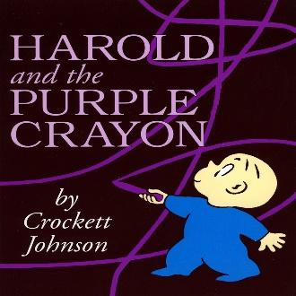
3.21: Harold and the Purple Crayon by Crockett Johnson (1955)
“One evening Harold decides to go for a walk in the moonlight. Armed only with an oversize purple crayon, young Harold draws himself a landscape full of wonder and excitement.
“Harold and his trusty crayon travel through woods and across seas and past dragons before returning to bed, safe and sound. Full of funny twists and surprises, this charming story shows just how far your imagination can take you.”
Video Link: https://www.youtube.com/watch?v=CLdHJgpeu2I (4:54)

3.22: Salad Pie by Wendy BooydeGraaff (Author) and Bryan Langdo (Illustrator) (2016)
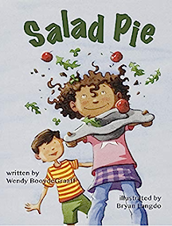
“There is nothing sweeter than arriving at the playground, seeing it empty, and knowing you have it all to yourself—the silent comfort of playing alone. Maggie is overjoyed to have that solitude to make her Salad Pie. But then Herbert saunters over and wants to play too. He just wants to help even though Maggie makes it clear she won’t let him. Then her imaginary pie takes a spill, and she realizes Herbert’s intentions are not so bad after all.”
Video Link: https://www.youtube.com/watch?v=5enlkOEZ5XU (5:36)

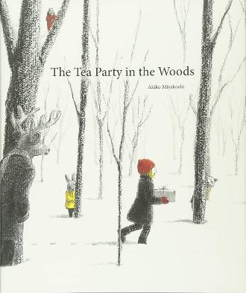
3.23: The Tea Party in the Woods by Akiko Miyakoshi (2015)
“When a young girl named Kikko realizes her father has forgotten the pie he was supposed to bring to Grandma’s house, she offers to try and catch him as he makes his way through the woods. She hurriedly follows her father’s footprints in the snow and happens upon a large house she has never seen before. Curious, Kikko peers through the window, when she is startled by a small lamb wearing a coat and carrying a purse. Even more surprising, the lamb speaks, asking her in a kind voice, ‘Are you here for the tea party?’ Suddenly, Kikko realizes her trip through the woods has turned into something magical.”
Video Link: https://www.youtube.com/watch?v=Y4ThNQxh-F0 (4:23)

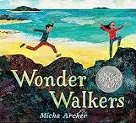
3.24: Wonder Walkers by Micha Archer (2021)
“When two curious kids embark on a “wonder walk,” they let their imaginations soar as they look at the world in a whole new light. They have thought-provoking questions for everything they see: Is the sun the world’s light bulb? Is dirt the world’s skin? Are rivers the earth’s veins? Is the wind the world breathing? I wonder….”
Video Link: https://www.youtube.com/watch?v=JL5isUTsDWU (2:04)

3.25: Outside In by Deborah Underwood, author and Cindy Derby, illustrator (2020)
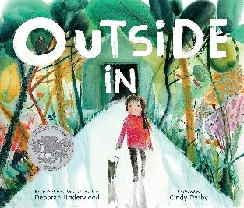
“Outside is waiting, the most patient playmate of all. The most generous friend. The most miraculous inventor. This thought-provoking picture book poetically underscores our powerful and enduring connection with nature, not so easily obscured by lives spent indoors.
“Rhythmic, powerful language shows us how our world is made and the many ways Outside comes in to help and heal us, and reminds us that we are all part of a much greater universe. Emotive illustrations evoke the beauty, simplicity, and wonder that await us all . . . outside.”
Video Link: https://www.youtube.com/watch?v=Xvubxi5EZYw (3:01)

3.26: Finding Wild by Megan Wagner Lloyd, author and Abigail Halpin, illustrator (2016)
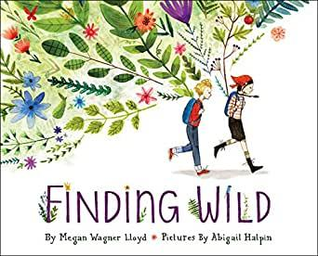
“There are so many places that wild can exist, if only you know where to look! Can you find it? Two kids set off on an adventure away from their urban home and discover all the beauty of the natural world. From the bark on the trees to the sudden storm that moves across the sky to fire and flowers, and snowflakes and fresh fruit. As the children make their way through the woods and back to the paved and noisy streets, they discover that wild exists not just off in some distant place, but right in their own backyard.”

Video Link: https://www.youtube.com/watch?v=yfoIOVxhhUg (5:00)

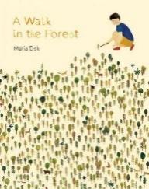
3.27: A Walk in the Forest by Maria Dek (2017)
“A Walk in the Forest is a stunning invitation to discover the woods as a place for both imaginative play and contemplation: collect pinecones, feathers, or stones; follow the tracks of a deer; or listen to the chirping of birds and the whisper of trees. Build a shelter and play hide-and-seek. Pretend the woods are a jungle, or shout out loud to stir up the birds! The forest comes alive in all its mysterious glory….”
Video Link: https://www.youtube.com/watch?v=i2jNuv5CyTs (2:44)

3.28: Backyard Fairies by Phoebe Wahl (2018)
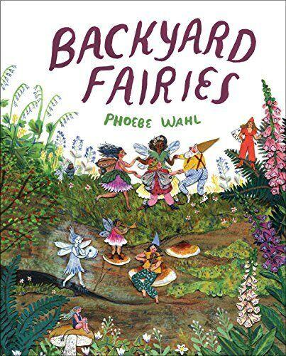
“A girl searches for fairies in her backyard and the woods beyond, following little clues and traces of magic. Fairies and other magical creatures can be found on every page, hidden among the flowers, trees and pebbles. But although readers can see them, the girl keeps searching, just one step behind... In the end, it is clear (both to the girl and readers) that there is magic all around, even when it’s hidden in plain sight.”
Video Link: https://www.youtube.com/watch?v=h0fGCK3RkW0 (2:38)

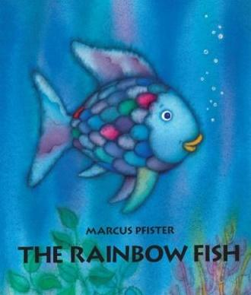
3.29: The Rainbow Fish by Marcus Pfister (1996)
“The rainbow fish with its iridescent scales is the most beautiful fish in the whole ocean. But since he is also vain and proud, he becomes more and more lonely over time. Then he realizes that you can’t win friends through beauty. He overcomes his pride and begins to distribute his glitter scales to the other fish.” Then the other fish invite him to play.”
Video Link: https://www.youtube.com/watch?v=tU5ot9R2p6A (4:16)

3.30: We’re Going on a Bear Hunt by Michael Rosen (Author) and Helen Oxenbury (Illustrator) (1989)
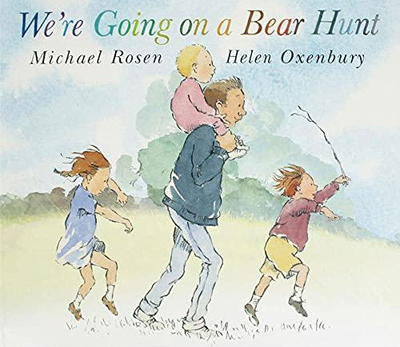
“‘We’re going on a bear hunt. We’re going to catch a big one.’
“Will you come too? Join a father and his four young children as they cross a field of tall, wavy grass, wade through a deep, cold river, struggle through swampy mud, find their way through a big, dark forest, fight through a whirling snowstorm, and enter finally enter a narrow, gloomy cave.”
Video Link: https://www.youtube.com/watch?v=riHxoHgphhU (4:20) (the words are sung)

3.31: The Recess Queen by Alexis O’Neill, author and Laura Huliska-Beith, illustrator (2002)

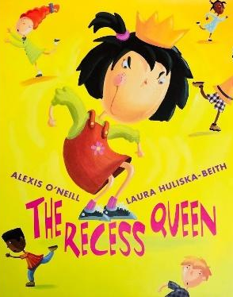
“A fresh & original twist on the common issue of bullying. Kids will relate, & parents & teachers will appreciate the story’s deft handling of conflict resolution (which happens w/o adult intervention)

“‘Mean Jean was Recess Queen and nobody said any different. Nobody swung until Mean Jean swung. Nobody kicked until Mean Jean kicked. Nobody bounced until Mean Jean bounced. If kids ever crossed her, she’d push ‘em and smoosh ‘em lollapaloosh ‘em, hammer ‘em, slammer ‘em kitz and kajammer ‘em. Until a new kid came to school!’ With her irrepressible spirit, the new girl dethrones the reigning recess bully by becoming her friend in this infectious playground romp.”

Video Link: https://www.youtube.com/watch?v=Mp3bKxYtnMM (6:58)

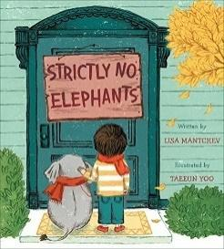
3.32: Strictly No Elephants by Lisa Mantchev, author and Taeeun Yoo, illustrator (2015)
“Today is Pet Club Day. There will be cats and dogs and fish, but strictly no elephants are allowed. The Pet Club doesn’t understand that pets come in all shapes and sizes, just like friends. Now it is time for a boy and his tiny pet elephant to show them what it means to be a true friend.”
Video Link: https://www.youtube.com/watch?v=d_f1zH0OlRw (2:59)

3.33: Pretend by Jennifer Plecas (2011)
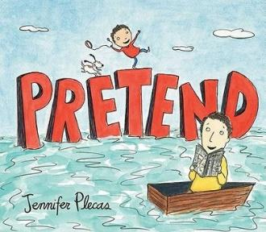
“What could have been a quiet afternoon at home turns into an adventure for Jimmy and his dad. Their couch turns into a boat! The staircase becomes a mountain! And blankets become a cozy hut, just right to cuddle inside. The one thing they don’t have to pretend is how much they love one another.”
Video Link: https://www.youtube.com/watch?v=jyxrn0GEFxI (6:20)

3.34: Rosie Revere, Engineer by Andrea Beaty, author and David Roberts, illustrator (2013)
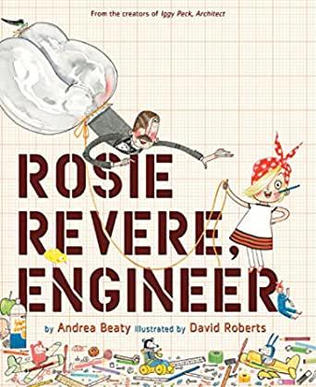
“Rosie Revere dreamed of becoming a great engineer. Where some people see rubbish, Rosie sees inspiration. Alone in her room at night, shy Rosie [playfully] constructs great inventions from odds and ends. Hot dog dispensers, helium pants, python-repelling cheese hats: Rosie’s gizmos would astound—if she ever let anyone see them.
“Afraid of failure, she hides them away under her bed. Until a fateful visit from her great-great-aunt Rose (AKA Rosie the Riveter!), who shows her that the first flop isn’t something to fear—it’s something to celebrate. And you can only truly fail, if you quit.”
Video Link: https://www.youtube.com/watch?v=31eBdgnPsCo (6:49)

3.35: Mae Among the Stars by Roda Ahmed, author & Stasia Burrington, illustrator (2018)
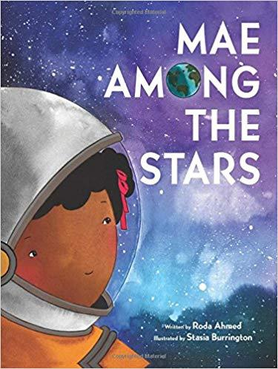
“When Little Mae was a child, she dreamed of dancing in space. She imagined herself surrounded by billions of stars, floating, gliding, and discovering.
“She wanted to be an astronaut.
“Her mom told her, “If you believe it, and work hard for it, anything is possible.”
“Little Mae’s curiosity, intelligence, and determination, matched with her parents’ encouraging words, paved the way for her incredible success at NASA as the first African American woman to travel in space.”
Video Link: https://www.youtube.com/watch?v=sF6CYDVdhyA (7:15)

4.0: Curriculum & Theme-Based Classroom Activities for Children

from Tapestry of Faith
4.1: Chalice Children: A Program about Our Unitarian Universalist Community for Preschoolers
4.1.1: Session 17: Wondering About Stars
Link: https://www.uua.org/re/tapestry/children/chalicechildren/session17
To wonder about stars can be play and playful engagement. Two of the books recommended for the lesson, Draw me a Star by Eric Carle, see https://www.youtube.com/watch?v=Jq9B5R7T2S0 (3:02), which is a different take on creation, and How to Catch a Star by Oliver Jeffers, see https://www.youtube.com/watch?v=rpyR6hJPxiw (4:59) are especially imaginative.
“Participants will:
- Experience a sense of wonder about stars and the night sky
- Express their sense of wonder through song, movement, and art
- Understand that wondering about stars is an experience we all share.”
4.1.2: Session 18: Wondering About the Moon
Link: https://www.uua.org/re/tapestry/children/chalicechildren/session18
Wondering about the moon invites play as children paint the moon on paper plates. A suggested book, Papa, Please Get the Moon for Me by Eric Carle, see https://www.youtube.com/watch?v=sGqAw7UM6qo (7:44) is especially playful. Also engaging is I Took The Moon For A Walk by Carolyn Curtis, see https://www.youtube.com/watch?v=Dn18y533hO8 (3:58) is a lovely example of playing.
“Participants will:
- Experience the wonder of the moon and the night sky
- Invent their own ideas of what the images in the moon are
- Connect a story with wondering about the moon.”
4.1.3: Session 20: Rainbows
Link: https://www.uua.org/re/tapestry/children/chalicechildren/session20
Rainbows are so magical for children that they invite playfulness. A recommended book, A Rainbow of My Own by Don Freeman, see https://www.youtube.com/watch?v=RDJ8_1En5bg (4:28) has the boy playing with a pretend rainbow, with a surprise at the end. Another book, How the Crayons Saved the Rainbow by Monica Sweeney, see https://www.youtube.com/watch?v=tfBnkYuYukw (3:30) is a playful story that leads to children painting rainbows.
“Participants will:
- Experience a shared sense of wonder
- Learn that their congregation is a place where questions and wondering are encouraged
- Connect the story they read in this session with their experiences of rainbows.”
4.1.4: Session 21: Dreams
Link: https://www.uua.org/re/tapestry/children/chalicechildren/session21
The meaning of dreams is often ambiguous, as may be clear as the children talk about their own dreams.
Dreaming is a kind of playing where we can be and go anywhere. What Will You Dream of Tonight? By Frances Stickley, see https://www.youtube.com/watch?v=_X7lwu-xYAU (4:25) introduces the wonder of dreaming, and supports the session. Another book, Day Dreamers: A Journey of Imagination by Emily Winfield Martin, see
https://www.youtube.com/watch?v=43nDHEO3OY0 (2:29) celebrates day dreaming, which is also play.
“Participants will:
- Explore the feelings associated with nighttime sleeping and dreaming
- Connect the story they read in this session with their sense of comfort and safety at bedtime
4.1.5: Session 22: Imagination
Link: https://www.uua.org/re/tapestry/children/chalicechildren/session22
Imagination as an unconscious process is at the center of playing. The book Journey by Aaron Becker, see https://www.youtube.com/watch?v=FMtc_QFIu9Q (2:57) beautifully illustrates the role of imagination in play through illustrations rather than words. Another book, What To Do With A Box by Jane Yolen & Chris Sheban, https://www.youtube.com/watch?v=AyFpB0xe0j8&t=82s (2:41)depicts how imagination can convert a box into many different things.
“Participants will:
- Express their imagination through art
- Experience a connection between imagination and creativity
- Understand that people of all ages can use their imagination to wonder and to express feelings.
- ting an engine or car to display in a group ‘Dream Train.’”

4.2: Creating Home: A Program on Developing a Sense of Home Grounded in Faith for Grades K-1
4.2.1: Session 1: On the Threshold
Link: https://www.uua.org/re/tapestry/children/home/session1
The story The Magic Vase is about imagination and beauty, while Alternate Activity 1: Building Homes Free Play encourages children through play to build dream homes.
Participants will:
- Practice ritual together using the chalice, the labyrinth, and name stones.
- Experience symbols by choosing and decorating a name stone to represent themselves.
- Learn about a “threshold” as a place of entrance and exit
- Explore the idea of journeying from and returning to home
- Physically explore the concepts of threshold, journey, and return, using the labyrinth.
- Learn the term “family home” and describe their own family home.
4.2.2: Session 8: Hare’s Gifts
Link: https://www.uua.org/re/tapestry/children/home/session8
In the story, Hare’s Gifts, Hare shares music and a drum with the community and everyone begins dancing, which is a form of play.
“Participants will:
- Experience cooperation in playing group games
- Learn about community as a gift after hearing the story, “Hare’s Gifts”
- Make music individually and together as a community activity”

4.3: Wonderful Welcome: A Program for Children Grades K-1
4.3.1: Session 6: The Gift of Friends
Link: https://www.uua.org/re/tapestry/children/welcome/session6
In the story, Coyote loses his songs, music, and dance, which means that he can no longer play. He only finds them when he reconciles with his friends, suggesting that friends can help us play.
“Participants will:
- Identify what they like about their friends
- Learn some ways to express appreciation of friends
- Reflect on the value of friends through a story about how the Native American character, Coyote, learns to value his friends
- Learn and sing a song about friendship.”

4.4: Love Surrounds Us: A Program on the UU Principles and Beloved Community for Grades K-1
4.4.1: Session 6: Acceptance
Link: https://www.uua.org/re/tapestry/children/lovesurrounds/session6
The story in this session, Odd Velvet, is a wonderful example of how children can play differently. Velvet has an amazing imagination that causes her to do unique things. See a reading of the book at https://www.youtube.com/watch?v=Jg-Fzg6mmkQ (4:59).
This session will:
- Introduce the Unitarian Universalist idea that all people are accepted in our congregations (third Principle)
- Affirm the call to welcome all into in our congregations
- Introduce the Buddhist concept of loving kindness.

4.5: Moral Tales: A Program on Making Choices for Grades 2-3
4.5.1: Session 3: Faith, Hope and Prayer
Link: https://www.uua.org/re/tapestry/children/tales/session3
The story, The Sword of Wood, is, at one level, a game of chess where the shah makes a move against the Jew to test his faith and the Jew makes a different move to find a new way to make money to live while professing his faith in God for helping him.
This session will:
- Introduce prayer as a powerful, optional spiritual practice
- Establish the importance of — and demonstrate how to give and receive — respect for all expressions of personal faith, regardless of personal beliefs or religious practices
- Engage participants in experiencing different types of prayer
- Explore the idea that actions can bring our prayers and wishes closer to reality
- Introduce and explicate a prayer bead necklace
- Highlight the third Unitarian Universalist Principle, acceptance of one another and encouragement of spiritual growth in our congregations
4.5.2: Session 6: Welcome One and All
Link: http://www.uua.org/re/tapestry/children/tales/session6
Mullah Nasruddin, a Muslim, Sufi, and wise man, often played the fool to teach important lessons. The story, Mullah Nasruddin Feeds His Coat, is a wonderful example of his playfulness to make a point.
This session will:
- Present welcome without prejudgment as a corollary to the first Unitarian Universalist principle: the inherent worth and dignity of every person
- Focus participants’ attention on the congregation as a place where everyone is welcome
- Highlight situations of exclusion and help participants develop empathy for those who are excluded
- Make a connection between justice and the inclusion of all people
- Foster welcoming of all people regardless of apparent differences
- Help participants recognize the injustice inherent in prejudgment
- Present a story about a man who is welcome at a feast only when he is wearing fancy clothing
- Involve participants in a game to game and act out welcoming and unwelcoming behaviors
- Invite participants to learn to sing the hymn, “We’re Gonna Sit at the Welcome Table.”

4.6: Faithful Journeys: A Program about Pilgrimages of Faith in Action for Grades 2-3
4.6.1: Session 5: Finding Balance
Link: https://www.uua.org/re/tapestry/children/journeys/session5
The story, Finding Balance, involves playing with a skateboard, which requires balance, and balancing haves with have-nots by raising money to share the love of skateboarding.
“Participants will:
- Develop an understanding of equity; learn that there is such a thing as having more than you need and such a thing as not having enough
- Learn how contemporary Unitarian Universalists, including children, have chosen to share resources to help others who have less
- Become empowered as agents of change who can identify practices of material excess and explore choices of voluntary simplicity
- Experience balance and centeredness as physical qualities and learn about them as qualities of lifestyle
- Generate and follow up on ideas to reduce, reuse, and recycle”

4.7: Love Will Guide Us: A Program for Grades 2-3 that Applies the Wisdom of the Six Sources to the Big Questions
4.7.1: Session 10: Love for All Creatures
Link: https://www.uua.org/re/tapestry/children/loveguide/session10
“Playing” by the God Ganesha in the story, The Cat, becomes hurtful. His mother tells him as a result, “Take care that in your play you do not injure others or cause them grief and fear.”
“Participants will:
- Learn the third Unitarian Universalist Source, in child-friendly language, ‘the ethical and spiritual wisdom of the world’s religions
- Learn about the Hindu religion through a story about the god Ganesha and exploration of the concept of ‘ahimsa’ (non-harm)
- Understand how wisdom from another religion, Hinduism, can guide Unitarian Universalists, with love, into right relation with animals
- Develop understanding of animal communication and deepen empathy toward animals.”

4.8: Signs of Our Faith: A Program about Being UU Every Day for Grades 2-3
4.8.1: Session 9: Looking for Signs of Community
Link: https://www.uua.org/re/tapestry/children/signs/session9
In this session, children play a game to reinforce the meanings of the story, “The Journey of the Birds
See “The Journey of the Birds” told by Jennifer McGlothin at https://www.youtube.com/watch?v=24YGvx-UMxQ (2:51)
“Participants will:
- Understand the congregation as a community to which they belong
- Play a game about building community
- Create a new community ritual.”
4.8.2: Session 11: Worshipping Together
Link: https://www.uua.org/re/tapestry/children/signs/session11
Participants will:
- Understand how UU congregational worship invites participants to share values and practices that are important
- Create and lead components of a typical worship service and discover how the components relate to each other.

4.9: Toolbox of Faith: A Program That Helps Children Discover the Uses of Faith, Grades 4-5
4.9.1: Session 16: Resiliency (Hard Hat)
Link: https://www.uua.org/re/tapestry/children/toolbox/session16
This session relies on play, i.e., dancing and singing a song, to reinforce the story, “Miriam: Sister, Prophet, Dancer.”
“Participants will:
- Learn to define resiliency as bouncing back from problems
- Hear the biblical story of a prophetic woman — Miriam, sister of Moses and Aaron —whose resiliency helped her lead her people from slavery
- Explore the structure and language of the Bible by searching for chapters and verses in a variety of versions
- Experience a Jewish dance and song as embodiment of the joy that Miriam felt upon the release from slavery
- Reflect on their own experiences of resiliency, including opportunities and strategies for being resilient in their own lives
- Engage in the spiritual practices of chalice lighting, voicing of joys and concerns, and intentional discussion.

4.10: Love Connects Us: A Program on Living in Unitarian Universalist Covenant for Grades 4-5
4.10.1: Session 3: Love is the Spirit of this Church
Link: https://www.uua.org/re/tapestry/children/loveconnects/session3
The “playing” of making a paper heart in the story, The Mish Mash Heart, leads to the sharing of a poignant story and the wisdom that flows from that.
“Participants will:
- Experience and respond to a story about how love becomes more powerful when it is given away
- Experience activities which require working together to accomplish an objective
- Understand how sharing joys and concerns together is one way people in a beloved community can support one another in good times and bad
- Reflect on how we all have a role in creating our beloved communities.”
4.10.2: Session 16: We are Active Creators of our Faith
Link: https://www.uua.org/re/tapestry/children/loveconnects/session16
The story, The Treehouse Rules, is about the way that children create a covenant to keep playing in the treehouse that the congregation had just constructed.
Participants will:
- Review their understanding of the Blake covenant and its application to their own lives and congregation
- Identify the value of creating covenants together
- Discover ways we are active creators of our faith.

4.11: Sing to the Power: A Social Justice Program for Children Grades 4-5
4.11.1: Session 2: The Power of Roots
Link: https://www.uua.org/re/tapestry/children/sing/session2
The poem, “Where I'm From,” focuses largely on playful memories of childhood. This is reinforced by Activity 2: "I am From...,” where participants write their own poem.
“Participants will:
- Consider the ways their roots and heritage ground them and shape who they are
- Describe where they are from—the places, stories, and people that have shaped them—and create poems using these images
- Express, in words and pictures, meaningful events that took place in their homes
- Consider how their roots and heritage may, and may not, shape their future.”

4.12: Riddle and Mystery: A Program on the Big Questions for Grade 6
4.12.1: Session 14: Life as Mystery
Link: https://www.uua.org/re/tapestry/children/riddle/session14
The story, “Why,” makes the point that at the end of mystery there is more mystery. Consider these discussion questions regarding play: What role does mystery have in play? What would happen to play, especially make believe, if there was no mystery? What makes play fun?
“Participants will:
- Understand mystery as natural and compelling to humans, and an experience celebrated in our faith
- Refresh their thoughts about Big Questions previously posed
- Hear Unitarian Universalist ideas about the nature and importance of questioning
- Identify the Big Questions most important to their lives
- Grow in comfort with questioning, accepting that questions sometimes produce ambiguous, contradictory answers
- Celebrate mystery.”

4.13: Circle of Trees: A Multigenerational Program about Nourishing Deep Connections with Nature
4.13.1: Workshop 3: Trees: Connected to All Life
Link: https://www.uua.org/re/tapestry/multigenerational/trees/workshop3
Activity 2: Guided Imagery—Among the Trees is an experience of play and the role of imagination. Ask participants the following: How was the guided imagery like play? What surprised them most about the experience?
“Participants will:
- Understand the concept of interdependence through the story “Trout Are Made of Trees”
- Reinforce their knowledge by playing the “Helping Tree Metaphors” game
- Build on their understanding of and respect for trees through multiple modes of learning, including movement, meditation, and song
- Experience multigenerational learning.”

4.14: Wisdom from the Hebrew Scriptures: A Multigenerational Program
4.14.1: Workshop 8: Creation
Link: https://www.uua.org/re/tapestry/multigenerational/hebrewscriptures/workshop8
The story, Creation, and Activity 3: Sabbath, are linked to Faith and Theology: The Good-for-Nothing Sabbath in the Touchstones Journal, where the purpose of the Sabbath is for prayer and play. This is one of the contemporary implications of the Creation story.
“Participants will:
- Explore the first Genesis story of Creation in the context in which it was written
- Respond to the text
- Explore contemporary implications of this story and consider its wisdom for their lives and the world
- Connect with people of all ages and be enriched by a variety of perspectives.”

4.15: Heeding the Call: A Program on Justice-making for Junior High School Youth
4.15.1: Workshop 9: The Call for Imagination
Link: https://www.uua.org/re/tapestry/youth/call/workshop9
Imagination is at the heart of play. The story, The Chair Men, is playful as is Activity 3: If I Were a Superhero. What would happen to play if it were devoid of imagination?
“Participants will:
- See imagination as an important quality in justice making and imagine ways to live out this commitment
- Explore the consequences of choices that involve a lack of imagination and an abundance of it, using global warming as an example
- Dream big about changing the world.

Resources for Youth
5.0: Curriculum & Theme-Based Classroom Activities for Youth
Tapestry of Faith
Youth
No sessions identified in Tapestry of Faith. Consider using 4.13.1, 4.14.1, and 4.15.1.

Play is critical for teenagers for following reasons.
- Intellectual Development: Play facilitates various aspects of intellectual development, including problem-solving skills, creativity, and critical thinking. It encourages teenagers to explore new ideas, experiment with different strategies, and think outside the box. Play provides opportunities to engage in abstract thinking.
- Emotional Regulation: The teenage years are characterized by intense emotional changes. Play serves as a valuable means for emotional expression and regulation. Teenagers explore and process complex emotions in a safe and controlled environment through play. It allows them to experiment with different roles, scenarios, and emotions, helping them better understand their feelings while strengthening healthy coping mechanisms.
- Social Skills and Relationships: Play creates opportunities for teenagers to interact with their peers, negotiate rules, cooperate, and resolve conflicts. It helps them develop communication, empathy, teamwork, and perspective-taking skills. Play fosters friendships and positive relationships through shared activities and common interests.
- Identity Formation: Adolescence is a period of self-discovery and identity formation. Play enables teenagers to explore different roles, values, and beliefs, leading to the development of a coherent sense of self. By engaging in imaginative play or trying out various activities, they can experiment with different aspects of their identity and better understand who they are and what they aspire to become.
- Stress Reduction and Well-being: The teenage years can be stressful due to academic pressures, peer relationships, and other challenges. Play is a natural stress reliever, offering an opportunity to relax, have fun, and experience joy. Playful activities can release endorphins, which contribute to feelings of happiness and reduce stress levels.
Play helps teenagers navigate the complexities of this transitional period while equipping them with essential skills and resilience for adulthood.

The preceding is informed by the article, The Importance of Play for Adolescents by Heather Hayes at https://www.heatherhayes.com/the-importance-of-play-for-adolescents/. For ideas about play activities for teenagers see Why Parents Should Encourage Their Teens to Play More by Kathi Valeii at https://www.parents.com/teens-and-play-what-it-looks-like-benefits-and-how-parents-can-support-their-kids-6890227.

6.0: Readings
6.1: Conscious Completion by Rosie Bell (153 words)
We …goal-oriented humans aren’t typically in the business of noticing life, while it’s happening. It is simultaneously our superpower and the greatest tragedy of our existence.
When I was little, my Dad worked in forests, and I often spent my school holidays playing in them. I particularly remember a fantastic house I once made out of sticks. I was so absorbed in construction that by the time it was perfect, it was also time to get in the car and go home. I never even sat in it. I would like to say that back then I was simply in flow and in nature, enjoying the journey with no thought for the destination. But I suspect that even by age 8 I had acquired precisely the opposite habit – becoming so lost in a plan for the future that I forgot to crawl into the beautiful, imperfect present and make the most of it.
Source: https://www.awakin.org/v2/read/view.php?tid=2522

6.2: Seven Properties of Play (302 words)
Stuart Brown, a psychiatrist and founder of the National Institute for Play, identified seven properties that highlight essential characteristics of play.
- Apparent Purposelessness: Play is often characterized by being intrinsically motivated and performed for its own sake rather than any external goal or reward. It may not have an apparent purpose or utility but is engaged simply for the joy and pleasure it brings. This does not mean there is no purpose, but the purpose can’t be discerned.
- Voluntary Participation: Play is a voluntary activity that individuals choose to engage in. It is not coerced or forced. People play willingly and are free to decide when to start and stop participating.
- Inherent Attraction: Play is inherently enjoyable and attracts individuals by its nature. It sparks curiosity, interest, and a sense of fascination, drawing people to engage willingly.
- Freedom from Time: Play exists outside the constraints of time. Individuals often lose track of time when immersed in play as they become absorbed in the experience. Play’s timelessness provides freedom from the pressures of schedules and deadlines.
- Diminished Consciousness of Self: During play, individuals often experience a sense of “flow,” where they become entirely focused and engaged in an activity. Immersion in play can lead to diminished self-awareness and a temporary escape from worries and concerns.
- Improvisational Potential: Play encourages spontaneous and flexible thinking. It provides opportunities for creativity, exploration, and experimentation. Playful activities often involve improvisation as the person playing adapts to changing situations.
- Continuation Desire: Play is an activity people want to continue engaging in. It sparks a desire for ongoing play, given the joy and satisfaction experienced.
These seven properties make clear that play is more complex and beneficial than is apparent. Research confirms that play is crucial for human development, well-being, and learning.
Source: Touchstones

6.3: The Sheep by Lewis Hyde (241 words)
Playing in the lot behind the house one day when he was still a little boy, Neruda discovered a hole in a fence board. “I looked through the hole and saw a landscape like that behind our house, uncared for, and wild. I moved back a few steps, because I sensed vaguely that something was about to happen. All of a sudden, a hand appeared---a tiny hand of a boy about my own age. By the time I came close again, the hand was gone, and in its place, there was a marvelous white toy sheep.
“The sheep’s wool was faded. Its wheels had escaped. All of this only made it more authentic. I had never seen such a wonderful sheep. I looked back through the hole but the boy had disappeared. I went in the house and brought out a measure of my own: a pine cone, opened, full of odor and resin, which I adored. I set it down in the same spot and went off with the sheep.
“I never saw either the hand or the boy again. And I have never seen a sheep like that either. The toy I lost finally in a fire. But even now...whenever I pass a toyshop, I look furtively into the window. It’s no use. They don’t make sheep like that anymore.”
… “This small and mysterious exchange of gifts remained inside me…, deep and indestructible, giving my poetry light.”
Source: https://www.awakin.org/v2/read/view.php?tid=981

6.4: Meaning: Where Monk and Child Meet by David Steindl-Rast (240 words)
The monk in us is very closely related to the child in us or, if you want, to the mystic in us — and we are all meant to be mystics.
…Now when I say that this has something to do with the child in us, I mean that there is in the child a longing to find a meaning, an openness to meaning which tends to be lost or at least overshadowed by our preoccupation with purposefulness.
…When you have to accomplish a particular purpose, the main thing is that you have to take things in hand.
…Now think of a situation in which something becomes meaningful to you. [...] Now you are not the one that keeps things under control and handles them and manipulates them; instead the experience does something to you. “It really touched me,” or if it is very strong, “It hit me over the head!” or, “It swept me off my feet!” — something like that. That’s when something becomes meaningful to you. So, what really happens is that you give yourself to it, and in that moment, it, whatever it may be, reveals its meaning to you. …This is not an either/or proposition. The two have to go together, but certainly in order to find meaning in our purposeful activities we have to learn to open ourselves, to give ourselves to what we are doing. And that is typically the attitude that the child takes.
Source: https://www.awakin.org/v2/read/view.php?tid=534

6.5: Relief Not Cure by Anthony DeMello (224 words)
Last year on Spanish television I heard a story about this gentleman who knocks on his son’s door. “Jaime,” he says, “wake up!” Jaime answers, “I don’t want to get up, Papa.” The father shouts, “Get up, you have to go to school.” Jaime says, “I don’t want to go to school.” “Why not?” asks the father. “Three reasons,” says Jaime. “First, because it’s so dull; second, the kids tease me; and third, I hate school.”
And the father says, “Well, I am going to give you three reasons why you must go to school. First, because it is your duty; second, because you are forty-five years old, and third, because you are the headmaster.” Wake up, wake up! You’ve grown up. You’re too big to be asleep. Wake up! Stop playing with your toys.
Most people tell you they want to get out of kindergarten, but don’t believe them. Don’t believe them! All they want you to do is to mend their broken toys. “Give me back my family. Give me back my job. Give me back my money. Give me back my reputation, my success.” This is what they want; they want their toys replaced. That’s all. Even the best psychologist will tell you that, that people don’t really want to be cured. What they want is relief; a cure is painful.
Source: https://www.awakin.org/v2/read/view.php?tid=301

6.6: Rough-and-Tumble Play & Empathy by Start Brown (269 words)
…Rough-and-tumble play …occurs in children both genders, but is a bit more obvious usually in boys. If you are to observe kids …in a preschool …and you watch them at play, it’s chaotic, anarchic, looks violent on the — to the surface. They’re diving. They’re hitting. They’re squealing. They’re screaming. But if you look at them, they’re smiling at each other. It’s not a contest of who’s going to win. And most well-meaning parents and a lot of, certainly, a lot of preschool teachers put the lid on that… because it’s …a little scary for an adult because they don’t remember. And almost, always has pretense and real. It has violence and fantasy, and it is the borderland between inside and outside in making sense of the world. It’s a very important part of free play driven from within by the child’s own personality and temperament in mixing with others.
…If, if you are in a rough-and-tumble situation, somebody hits you too hard, you know what that feels like. So, you’re not going to hit …somebody else too hard, because you know what it feels like. And that’s the root …of an empathic response. …If you extrapolate …rough-and-tumble play backwards into animals, they also appear to need it to be able to properly find their place in the troop …or the pack and develop a social reality to meet their needs.
…There has to be reasonable protection by adults, but not the kind of helicopter parent hovering over the situation, which prevents the spontaneity from occurring and the kids from solving their own problems that are age appropriate for them.
Source: https://onbeing.org/programs/stuart-brown-play-spirit-and-character/

6.7: Catching Bubbles by Les Kaye (121 words)
Imagine a child trying to catch a soap bubble. After playing with bubbles for a short time, the child learns their nature. He understands that they are insubstantial and gives up trying to catch them. He understands the nature of bubbles without thinking about it. He doesn’t say to himself, “I understand. These bubbles have no permanent nature.”
…It is fruitless for us to try to grasp wisdom and peace of mind. We should simply let practice be the basis of our lives. Then our inherent wisdom can reveal itself. Then we can realize our inherent completeness and we can see that there is no need to obtain or grasp anything. That is how we learn to appreciate and enjoy bubbles.
Source: https://www.awakin.org/v2/read/view.php?tid=89

6.8: Finite and Infinite Games (196 words)
Finite and Infinite Games is a 1986 book written by James Carse. It explores the concept of games and how they relate to various aspects of life.
Carse distinguished between finite games and infinite games. Finite games have defined rules and a clear beginning and end. The primary goal is to win. Examples include sports, board games, and business negotiations.
By contrast, infinite games have no fixed rules or endpoints. The goal is to keep playing. Infinite games include life, relationships, and certain forms of art. In infinite games, the players are not competing against each other but are engaged in an ongoing process of exploration, discovery, creativity, and, sometimes, collaboration.
Many aspects of life can be seen through the lens of infinite games. Carse suggested that embracing the mindset of an infinite player can lead to a more fulfilling and meaningful life. This mindset consists of curiosity, openness, and a willingness to adapt to new situations. Infinite players are not concerned with winning or losing but with participating fully in the ever-evolving “game” of life.
Given this, we are encouraged to reexamine our understanding of competition, success, and pursuing goals by embracing an infinite mindset.
Source: Touchstones

6.9: Play Needs No Purpose by Parker Palmer (237 words)
Remember when all the best “futurists” assured us that technology would reduce everyone’s workload, leaving us with a lot more time for play? Well, I have a word for those false prophets: NOT!
Every day I struggle to resist the siren call of work that comes via my computer and my smart phone, trying to protect time for such simple stuff as reading a novel, walking in the woods, or joking and jiving with friends. Every day I have to re-learn the old lesson, “All work and no play makes Jack — or Parker — a dull boy.” I may have a smartphone, but my phone has a dumb owner!
That’s why I love this …from Br. David Steindl-Rast, a Benedictine monk with a Ph.D. in experimental psychology who’s the co-founder of A Network for Grateful Living: “Play needs no purpose. That is why play can go on and on as long as players find it meaningful. After all, we do not dance in order to get somewhere. We need this kind of experience to correct our worldview.”
…Next time you go out, watch the birds as they swoop and soar in the sheer joy of flight. As you do, remember that, even though we don’t have wings, somewhere in us is that kid who took flights of fancy as he or she played. Then find a park, get on the swing, and let your inner bird take wing!
Source: https://onbeing.org/blog/play-needs-no-purpose/

6.10: The Play Deficit by Peter Gray (267 words)
When I was a child in the 1950s, my friends and I had two educations. We had school (which was not the big deal it is today), and we also had what I call a hunter-gatherer education. We played in mixed-age neighborhood groups almost every day after school, often until dark. We played all weekend and all summer long. We had time to explore in all sorts of ways, and also time to become bored and figure out how to overcome boredom, time to get into trouble and find our way out of it, time to daydream, time to immerse ourselves in hobbies, and time to read comics and whatever else we wanted to read rather than the books assigned to us. What I learned in my hunter-gatherer education has been far more valuable to my adult life than what I learned in school….
For more than 50 years now, we …have been gradually reducing children’s opportunities to play. …Beginning around 1960 …, adults began chipping away at that freedom by increasing the time that children had to spend at schoolwork and …by reducing children’s freedom to play on their own, even when they were out of school and not doing homework. Adult-directed sports for children began to replace ‘pickup’ games; adult-directed classes out of school began to replace hobbies; and parents’ fears led them, ever more, to forbid children from going out to play with other kids, away from home, unsupervised. …The effect, over the decades, has been a continuous and ultimately dramatic decline in children’s opportunities to play and explore in their own chosen ways.
Source: https://aeon.co/essays/children-today-are-suffering-a-severe-deficit-of-play

6.11: Deep Play and Higher Consciousness by Diane Ackerman (268 words)
Deep play is the ecstatic form of play. In its thrall, all the play elements are visible, but they’re taken to intense and transcendent heights.
…Deep play always involves the sacred and holy, sometimes hidden in the most unlikely or humble places — amid towering shelves of rock in Nepal; crouched over print in a dimly lit room; slipping on AstroTurf; wearing a coconut-shell mask. We spend our lives in pursuit of moments that will allow these altered states to happen. The Australian Aborigines search for it on wilderness treks called walkabouts, during which young men of the tribe go alone into the dangerous outback to gain strength and wisdom. Buddhist lamas and Hindu sadhus travel, nearly naked, to pray atop glacial mountains in Tibet. People from many cultures have gone on soul journeys into the wilderness, where risk, hunger, pain, exhaustion, and sometimes self-torture might inspire visions. Young Masai men set off on a pilgrimage to Mount Kilimanjaro, the sacred center of their world, as part of the initiation rite known as Moranism. Native Americans have often used ritualized running to scale mental heights. The Hopis stage many such races every year, featuring paint, costumes, fasts, and prayer. The Crow Indians run to exhaustion to persuade the gods that they deserve good luck. The Zuni run twenty to forty miles while kicking a sacred stick. The official purpose of these ordeals may be religious, but the physiological goal is to impel the initiate into a higher state of consciousness that kindles visions and insights, in a locale where survival may depend on a combination of ingenuity and nerve.
Source: Deep Play by Diane Ackerman

6.12: Play is the Thing by Peter Gray (271 words)
Learning versus playing. That dichotomy seems natural…. Learning …is what children do in school… Playing is …a refreshing break from learning. …Summer vacation is just a long recess…. But …playing is learning. At play, children learn the most important of life’s lessons …that cannot be taught in school. To learn these lessons well, children need lots of play …without interference from adults.
…Most play is social play. Social play is the academy for learning social skills.
The reason why play is such a powerful way to impart social skills is that it is voluntary. Players are always free to quit, and if they are unhappy, they will quit. Every player knows that, and so the goal, for every player who wants to keep the game going, is to satisfy his or her own needs and desires while also satisfying those of the other players, so they don’t quit. Social play involves lots of negotiation and compromise. …To have fun in social play you have to be assertive but not domineering; that’s true for all of social life.
…The golden rule of social play is not ‘Do unto others as you would have them do unto you.’ Rather, it’s something much more difficult: ‘Do unto others as they would have you do unto them.’ To do that, you have to get into other people’s minds and see from their points of view. Children practice that all the time in social play. The equality of play is not the equality of sameness. Rather, it is the equality that comes from respecting individual differences and treating each person’s needs and wishes as equally important.
Source: https://aeon.co/essays/children-today-are-suffering-a-severe-deficit-of-play

6.13: The Cosmic Play by David Zeller (268 words)
The main form of entertainment for the people here were plays called leela, with musical accompaniment that acted out the main stories of their religion. These were usually family productions, with families carrying this on from generation to generation. They started very young, playing simple instruments and working with various props. Then they took on the major roles in the play. As they got older, they became more accomplished as musicians or got more involved with costumes and props; as that occurred, the elders would become the directors and conductors. There were two productions in town: one for the “common” people, who flocked to these plays in droves as we might go to the movies, and one for the spiritually elevated, the gurus and priests of the community. I was privileged to be invited to the latter.
The play was beautiful, with its sets, costumes, music, and acting. It centered on a heroine who was searching for her lover, who had disappeared. It was a metaphor for each person looking for God, who is hidden from us. She went everywhere, asking, “Have you seen my beloved?” Everyone replied that he or she hadn’t seen him. I was appreciating the play from an artistic perspective. But as I looked around at the audience, I saw that they were all crying: they’d totally identified with the woman’s longing for her beloved. For me, this was excellent entertainment; for them, it was reality. Once again, I was seeing that there is a separate reality of God, and that every “drama” and trauma in our life is God’s leela, God’s cosmic play.
Source: The Soul of the Story by David Zeller

6.14: Innate Talents by Stuart Brown (228 words)
…Go to the Oxford dictionary and you’ll find at least 50 definitions [of play], but …I’d say play is anything that spontaneously is done for its own sake. And then one can extend that into more and more detailed definitions such as “appears purposeless,” “produces pleasure and joy,” “leads one to the next stage of mastery.” In terms of biology, “appears to be the product of,” what I call, “divinely superfluous neurons.” There is choice in the player’s life. And that choice, if given opportunities through the environment, emerges innately and spontaneously if the individual, or animal for that matter, that’s capable of playing is safe and well fed.
… [Take] a child over 3 but under 12. …If you just observe them and don’t try and direct them and watch what it is they like to do in play, you often will see a key to their innate talents. And if those talents are given fairly free reign, then you see that there is a union between self and talent. And that this is nature’s way …of saying this is who you are and what you are. …If you go back and think about …your children or yourself and …your earliest emotion-laden, visual, and visceral memories of what really gave you joy, you’ll have some sense of what was natural for you and where your talents lie.
Source: https://onbeing.org/programs/stuart-brown-play-spirit-and-character/

6.15: Play Washes Ambition Out of the Soul by Joan Chittister (279 words)
Here we see again what far too many of us forgot far too long ago: there is something about taking the time to do nothing important that is important. Play washes ambition out of the soul. Instead, it is about doing something simply for the pure joy of doing it. For one brief moment in the midst of striving to stay alive, there is no product to be produced, no personal gain to be sought, nothing to prove. That may be why childhood is so largely devoted to play, to the exhilaration of aimlessness. It is the one period in life when we are allowed to wallow in the understanding that just being alive is enough for us.
…Play ...teaches us the joy of freedom and gives us the right to break all the rules: we can dirty our shoes, laugh out loud, slide in the grass and blow bubbles to nowhere, and no one will care. It enables us to stop taking ourselves too seriously, an insight of eternal importance if we are to live well with others and be able to bear our own failures later when being able to fail becomes our greatest success in life.
We learn, too, that, in the end, life is itself a “house of cards” built to collapse — however much the strain or tension, skill or concentration we give it as we go. Play exposes us to the fact that there is nothing we ever do in life …that is permanent. Only that simple lesson itself is permanent. And, in the end, that may well be enough to carry us calmly and expectantly from one of life’s games to the next.
Source: https://www.spiritualityandpractice.com/book-reviews/excerpts/view/24716

6.16: Play as Re-creation by Patrick Thomas Malone and Thomas Patrick (250 words)
Play is any activity we engage in that has no intention and no goal. It is activity simply for the experience of being active and actively being. Seen as such, we can easily understand how so little play occurs in our society. We are full of intentions and goals. Visiting fitness centers to get in shape, …playing tennis to win the division championship are not ways of playing.
…We cannot force ourselves to play, nor can we coerce ourselves into engagement. …Seeing and searching, whether by a physicist searching for a new particle or a child searching for a four-leaf clover, will be playful only if it is real. The true explorer is the playful wanderer, not the man on a mission. Play is always nonintentional.
…We forget that filling up leisure time, exhausting ourselves, and external risk-taking are not playing. Playing is re-creation, an experience of self.
…We are re-created each time we play. That is the true risk…. We risk change…. We risk being reborn. …We risk our past to be here. We risk our future to be now.
Understanding that play is the fundamental learning context has tremendous implications for our educational system. Sadly, that system now seems very out of touch with learning as opposed to informing. All teaching that is not grounded in play simply informs. …Informing …becomes the re-experiencing of the previous learning. It becomes a confirming enhancement of what is already known.
...Unimpeded, all humans will play. And while playing we will learn.
Source: https://www.spiritualityandpractice.com/book-reviews/excerpts/view/21217

6.17: Action Without Desire Of Outcomes by Vinoba Bhave (200 words)
If one cooks for the joy of cooking, and with full attention and presence of mind, then good cooking will be a natural outcome. Garden for the joy of gardening, without impatience and without anxiety, then fruit, flowers and vegetables will flow from the garden of their own accord. Those who are devoted to cooking or gardening will not feel satisfied if we say to them that they need not cook or garden, we will provide ready-made meals and pre-packed vegetables. A true cook or gardener will not feel happy, because in that way they have been deprived of their creativity and joyful work.
A gardener, while gardening with love, identifies with the vegetable kingdom. Through gardening he or she attains oneness with the whole universe. That way gardening becomes a noble act, a spiritual act, a prayer and a play -- all life is a play; a divine drama. A child plays for the joy of playing; we act for the joy of acting. We should perform our actions as naturally as a bird sings. We need not expect recognition for acting according to our own nature. Gardening comes to a gardener as naturally as eating, drinking or sleeping.
Source: https://www.awakin.org/v2/read/view.php?tid=2274

6.18: Who Am I? by Author Unknown (258 words)
A mother and her young son went to the busy market place and got separated. After frantically searching for her son throughout the market, his mother finally found him playing beside a toy stall, “Weren’t you worried when you got lost?” cried the mother. The boy replied, “I was not lost, I was here all the time.”
Amidst the anomalies and mysteries of life, we are often dumbfounded and lost. But this is not very surprising considering that even a very basic question—who are you? —can quite easily stumble most of us; if we ask someone that question, we are likely to get many different responses. The funnier thing is that the same person will answer differently at various stages of his/her life. This is simple proof of the ambiguity behind this question. In fact, with the advent of Quantum Physics, even science is confused about the question. So, what is the common solution to this enigma? Evading it. Most people just forget about the question and continue with their lives as if the question weren’t important. But that seems rather silly; how can one operate something without knowing what it is? Perhaps that is the reason for our misery. Perhaps upon understanding ourselves, we will find the roots of our happiness and sorrow.
Finding ourselves isn’t an external journey; instead, when we find our self within us, we will be reminded of the little boy’s words— “I was here all the time.” Meditation, then, is our noble attempt to answer this most basic question.
Source: https://www.awakin.org/v2/read/view.php?tid=20

6.19: The Cosmic Café by Marney Makridakis (253 words)
Fourteenth-century Christian mystic Henry Suso is thought to be the first to use the term ludus amoris, which is Latin for “game of love” — a term that describes divine play and that has continued to be used in mystical traditions. A tradition I find particularly playful — and extremely helpful during challenging times — is the Hindu interpretation of sacred play.
The Sanskrit word lila, like many Sanskrit words, cannot be literally translated to English but can be loosely translated as “play.” It refers to the Hindu tradition wherein all reality is seen as play and our lives are thought to be the outcome of creative play by the Divine.
It is this concept that inspires one of the most playful ways to get through a challenging time: imagine that you are an actor on a cosmic stage, given a role to perform …with many difficult circumstances, and see what you can make out of them. You rise from your chair, enter the role without the emotional drains that so often accompany personal drama: no guilt, shame, pressure, or expectation. You simply put on your costume and enter stage right.
It is said that when we make plans, God laughs. When you embrace sacred play, you get to laugh, too. During one of the most difficult challenges of my life, this playful method saved me and provided the perspective I needed to rise each day and decide to take on the role of playing me, intrinsically connected to the much bigger cosmic café of life.
Source: https://www.spiritualityandpractice.com/book-reviews/excerpts/view/27654

6.20: The Core of Contemplative Life by Patricia Hampl (197 words)
For moderns—for us—there is something illicit, it seems, about wasted time, the empty hours of contemplation when a thought unfurls, figures of speech budding and blossoming, articulation drifting like spent petals onto the dark table we all once gathered around to talk and talk, letting time get the better of us. Just taking our time, as we say. That is, letting time take us.
“Can you say,” I once inquired of a sixty-year-old cloistered nun who had lived (vibrantly, it seemed) from the age of nineteen in her monastery cell, “what the core of contemplative life is?”
“Leisure,” she said, without hesitation, her china blue eyes cheerfully steady on me. I suppose I expected her to say, “Prayer.” Or maybe “The search for God.” Or “Inner peace.” Inner peace would have been good. One of the big-ticket items of spirituality.
She saw I didn’t see.
“It takes time to do this” she said finally.
Her “this” being the kind of work that requires abdication from time’s industrial purpose (doing things, getting things). By choosing leisure she had bid farewell to the fevered enterprise of “getting-and-spending” whereby, as the poet said, “we lay waste our powers.”
Source: https://www.spiritualityandpractice.com/book-reviews/excerpts/view/16407

7.0: Popular Music
7.1: The Circle Game by Joni Mitchell A & Buffy Saint Marie B
Video Link A: https://www.youtube.com/watch?v=5NEkJhBHh54 (4:55)
Video Link B: https://www.youtube.com/watch?v=PqjdtUn9lKo (3:02)
7.2: Happy by Pharrell Williams (4:00)

Video Link: https://www.youtube.com/watch?v=ZbZSe6N_BXs
7.3: See Emily Play by Pink Floyd (2:48)
Video Link: https://www.youtube.com/watch?v=7c0EDM-Yu9o
7.4: Video Game (with lyrics) by Sufjan Stevens (4:37)
Video Link: https://www.youtube.com/watch?v=x4Y6YNCf-ow
7.5: The Play by Peter Mayer (5:12)
Video Link: https://www.youtube.com/watch?v=ADl_q5u9dlU
7.6: Blue Boat Home by Peter Mayer (4:02)
Video Link: https://www.youtube.com/watch?v=WhsXl1_rEwI
7.7: Jama Day by Peter Mayer (2:59)
Video Link: https://www.youtube.com/watch?v=oMgNf1yJnTY
7.8: Snuffleupagus by Peter Mayer (3:30)
Video Link: https://www.youtube.com/watch?v=mhKVKA-jBEA
7.9: Magical World by Peter Mayer (3:56)
Video Link: https://www.youtube.com/watch?v=xJxuYCacxog
7.10: Ocean Mary by Peter Mayer (4:08)
Video Link: https://www.youtube.com/watch?v=kVny6DpdGuw
7.11: Astronaut Dreams by Peter Mayer (4:05)
Video Link: https://www.youtube.com/watch?v=I4kwe-uVcZM
7.12: Running with the Buffalo by Peter Mayer (4:30)
Video Link: https://www.youtube.com/watch?v=7r0gc715Uq4
7.13: Molly O’Malley’s by Peter Mayer (3:26)
Video Link: https://www.youtube.com/watch?v=hpFndFQVTFM
7.14: Fall by Peter Mayer (3:01)
Video Link: https://www.youtube.com/watch?v=1rQMMDpwjCs
7.15: Camping By the Sun by Peter Mayer (4:37)
Video Link: https://www.youtube.com/watch?v=Y7WTfQo4DoU
7.16: Could You Be by Peter Mayer (4:37)
Video Link: https://www.youtube.com/watch?v=vkXD9Ii74U8

8.0: Videos
8.1: Importance of Play by Dr. Jeffrey Trawick-Smith (2:37)
“Research shows that play has an essential role in children’s learning. …Dr. Jeffrey Trawick-Smith discusses the importance of play and advises early childhood professionals to look at several elements of children’s play, including engagement in make-believe play, social interaction during play, and play complexity. Teachers who enhance children’s play can help promote children’s development in a variety of domains.”
Video Link: https://www.youtube.com/watch?v=vnH4Ijen7OI

8.2: The Power of Play by UNICEF South Africa (4:59)
“Play is a natural part of childhood and is inherently human. Play is an important way for children to acquire new knowledge and skills from birth. Play can take many forms. When children play, they learn to socialize, and they develop early foundational concepts in math, science, geography, the universe and virtually all aspects of existence.
“The brain thrives on experiences that establish new neural connections.”
Video Link: https://www.youtube.com/watch?v=C3No2_ObHLY

8.3: The Importance Of Real Play by PersilUK (2:05)
A good overview of the value of lay for children.
Video Link: https://www.youtube.com/watch?v=QhHZkTo7MKk&t=2s

8.4: Importance of Play by Karen Hutchison (2:15)
“Rowan University Professor Karen Hutchison talks about the importance of play for young children.”
Video Link: https://www.youtube.com/watch?v=t5JyA0m2TvE

TED Talks
8.5: The Transformative Power of Play by Emeka Nnadi (14:50)
“I am an urban designer, landscape architect and development consultant committed to making the world a better place through the playful application of emerging, innovative technologies in the development of places and spaces where people live, work and play. I’m motivated by wonder, play, and technology as catalysts for humanity’s future. I’m passionate about community development and urban design solutions which integrate quality of life goals with economic and environmental sustainability. It is very exciting to share something that has excited me for most of my professional life.”
“How old are you?” said the queen. (White Queen)
“I’m seven and a half exactly” (Alice)
“You needn’t say “exactly” the queen remarked: “I can believe it without that. Now I’ll give you something to believe. I am just one hundred and one, five months and a day”
“I can’t believe that!” said Alice.
“Can’t you?” the Queen said in a pitying tone. “Try again: draw a long breath, and shut your eyes.”
Alice laughed. “There’s no use trying,” she said: “one can’t believe impossible things.”
“I daresay you haven’t had much practice,” said the Queen. “When I was your age, I always did it for half-an-hour a day. Why, sometimes I’ve believed as many as six impossible things before breakfast.”
Video Link: https://www.youtube.com/watch?v=mXxHKvq1wbc

8.6: Play is more than just fun by Stuart Brown (26:42)
“A pioneer in research on play, Stuart Brown says humor, games, roughhousing, flirtation and fantasy are more than just fun. Plenty of play in childhood makes for happy, smart adults -- and keeping it up can make us smarter at any age.”
Video Link: https://www.youtube.com/watch?v=HHwXlcHcTHc&t=2s

8.7: The decline of play by Peter Gray (16:03)
“In this talk, Dr. Peter Gray compellingly brings attention to the reality that over the past 60 years in the United States there has been a gradual but, overall dramatic decline in children’s freedom to play with other children, without adult direction. Over this same period, there has been a gradual but overall dramatic increase in anxiety, depression, feelings of helplessness, suicide, and narcissism in children and adolescents. Based on his own and others’ research, Dr. Gray documents why free play is essential for children’s healthy social and emotional development and outlines steps through which we can bring free play back to children’s lives.”
Video Link: https://www.youtube.com/watch?v=Bg-GEzM7iTk

8.8: 5 dangerous things you should let your kids do by Gever Tulley (9:20)
“Gever Tulley, founder of the Tinkering School, spells out 5 dangerous things you should let your kids do.”
Video Link: https://www.youtube.com/watch?v=C-VacaaN75o

8.9: The Power of Play by Ash Perrin (15:52)
“Can play heal the wounds inflicted by displacement and social exclusion? The answer, according to Ash Perrin, is unequivocally yes. As the founder of a nonprofit that brings play and laughter to marginalized children, Perrin works with children in refugee camps who are living in acutely difficult circumstances. They show clear signs of trauma—withdrawal, anxiety, hostility, and suspicion—and their experiences lead them to seek self-preservation through aggression and to see other people as threats. But play has the power to change that. Play builds social bonds, teaches conflict resolution, develops resilience, promotes self-esteem, and fosters joy. In a world riven by conflict and increasingly invested in digital rather than personal connections, we must be proactive in preserving traditional forms of physical play because play and laughter are our one global language.”
Video Link: https://www.youtube.com/watch?v=VNAtVKLxjnA

8.10: Never Too Old to Play: Rethinking American Playgrounds by Meghan Talarowski (13:41)
“Remember the playgrounds of your childhood? The giant swings and warp speed merry go rounds? But look around today and find a sea of rubber and plastic “bubble wrapped” play. Find out how American playgrounds can “spark joy” again, for all ages. Meghan Talarowski is the founder and director of Studio Ludo, a non-profit dedicated to building better play through research, design, and advocacy. She has degrees in architecture and landscape architecture, over 15 years of experience in the design field, and is a certified playground safety inspector. Her research focuses on how the design of play environments impacts physical health and social behavior, and has been presented at conferences worldwide.”
Video Link: https://www.youtube.com/watch?v=WMOlZShrr68

8.11: The importance of play by John Cohn (18:27)
“Dr John Cohn (@johncohnvt) is a self-confessed nerd. He already knew he wanted to be an engineer at the age of eight, found himself a nerdy college, a nerdy job and even a nerdy wife, or at least a fellow-engineer. As a nerd he breaks the mold though. Because onstage, with his rainbow-colored lab coat, his Einstein-inspired hairdo and his party light headband, he is most of all entertaining and fun. That ties in with his motto: keep things playful. Bring a playful spirit into your work.
“John says he is at his most creative, influential, productive and happy when he is playful at his work. With playful he means being in a state of childlike innocence. So playfulness is not just about enjoying your work, you are even more creative, as studies show. You can also reclaim that childlike state, by imagining you are still seven years old.
“Life however, has a way of taking play away from us. The harder life gets, the more we have to work at staying playful. If work is not playful anymore, then it is just work. Which is why they call it work, incidentally. Six years ago, life became very difficult for John, when his son Sam died in a car crash. Sam was an organ donor, and when his life ended, he saved the life of four other people. Needless to say, John’s life changed forever. And trying to get his life back on track involved a playful element, although he didn’t think of it like that at the time. John and his family started making SamStones, small stones with Sam’s name on it. Now, over six years later, some 40,000 SamStones have travelled all over the world, and each stone tells a story. One of them even went to space and back.
“Life will give you reasons not to play, and you have to fight back!”
Video Link: https://www.youtube.com/watch?v=I-NT1-BdOvI

8.12: Evolution’s gift of play, from bonobo apes to humans by Isabel Behncke (7:01)
“With never-before-seen video, primatologist Isabel Behncke Izquierdo shows how bonobo ape society learns from constantly playing -- solo, with friends, even as a prelude to sex. Indeed, play appears to be the bonobos’ key to problem-solving and avoiding conflict. If it works for our close cousins, why not for us?”
Video Link: https://www.youtube.com/watch?v=WjBwhwe5-cc

8.13: 5 dangerous things you should let your kids do by Gever Tulley (9:20)
“Gever Tulley, founder of the Tinkering School, spells out 5 dangerous things you should let your kids do.”
Video Link: https://www.youtube.com/watch?v=C-VacaaN75o

8.14: The Power of Play by Charlie Hoehn (13:44)
Why are so many people in the world burned out at what they do? I felt dead inside and had no idea how to fix it. I started to incorporate play in my life and in one month I was back to normal.
“If you’ve never Googled the phrase “cure anxiety,” then you might not know that the #1 result in the world was written by Charlie Hoehn. Millions of people have read his articles on mental wellness, and his bestselling book ‘Play It Away: A Workaholic’s Cure for Anxiety’ was called “The cure to your stress!” by Tony Robbins. Charlie has keynoted at military bases around the U.S., including the Pentagon, on how to prevent soldiers from committing suicide.”
Video Link: https://www.youtube.com/watch?v=uMP8h7fPpoY

